**PERSONAL BLOG ON IBM CLOUD STATIC WEB APP**

DESIGN AND DEVELOPMENT OF PERSONAL BLOG:

1.PLAN YOUR CONTENT:

Determine what information you want to including on your webpage. This might include an about section, your resume, portfolio, contact information and more.

2. CHOOSE A DOMAIN

Decide on a domain name for your website. You can purchase a domain from various registrars.

3.SELECT A HOSTING PROVIDER:

Choose a web hosting provider to store your website files. Popular options include Bluehost, Site Ground or GitHub page for statics sites.

4.DESIGN YOUR PAGE

Create a simple and appealing design for your webpage. You can code it yourself using HTML, CSS.

5.CONTENT CREATION:

Write the content for your web pages. Ensure it’s well-organized and engaging.

6.WEBSITE DEVELOPMENT:

If coding yourself, create your web pages you see HTML for structure and CSS for styling. Make it responsive for various screen sizes.

7.TESTING:

Test your website in different browsers and devices to ensure it looks and functions as expected.

8.DOMAIN SETUP:

Configure your domain to point to your hosting provider’s servers.

9.PUBLISH:

Upload your website files to the hosting server.

10.SEO OPTIMIZATION:

Optimize your website for search engines by using proper meta tags and keywords.

11.REGULAR UPDATES:

Keep your webpage updated with new information and content.

12.PROMOTE YOUR PAGE

Share your website on social media and include the URL in your mail signature.

13.SECURITY:

Ensure the security of your website by using HTTPS, strong passwords and security plugins if you’re using a content management system.

14.ANALYTICS:

Use tools like Google Analytics to monitor traffic and user behavior on your website.

PROGRAM:

<!DOCTYPE html>

<html lang="en">

<head>

<meta charset="UTF-8">

<meta name="viewport" content="width=device-width, initial-scale=1.0">

<title>My Travel Adventures</title>

<link rel="stylesheet" href="styles.css">

</head>

<body>

<header>

<h1>Welcome to My Travel Adventures</h1>

<nav>

<ul>

<li><a href="#home">Home</a></li>

<li><a href="#stories">Stories</a></li>

<li><a href="#tips">Tips</a></li>

<li><a href="#photos">Photos</a></li>

</ul>

</nav>

</header>

<section id="home">

<h2>Explore the Beauty of the World!</h2>

<p>Join me on my journeys and discover amazing places.</p>

</section>

<section id="stories">

<h2>Travel Stories</h2>

<article>

<h3>Adventures in [Destination]</h3>

<p>...</p>

</article>

<!-- Add more travel stories -->

</section>

<section id="tips">

<h2>Travel Tips</h2>

<article>

<h3>Top [Number] Tips for [Destination]</h3>

<ul>

<li>Tip 1: ...</li>

<li>Tip 2: ...</li>

<!-- Add more tips -->

</ul>

</article>

<!-- Add more travel tips -->

</section>

<section id="photos">

<h2>Travel Photos</h2>

<div class="photo-gallery">

<img src="photo1.jpg" alt="Photo 1">

<img src="photo2.jpg" alt="Photo 2">

<!-- Add more photos -->

</div>

</section>

<footer>

<p>&copy; 2023 My Travel Adventures. All rights reserved.</p>

</footer>

</body>

</html>

<!DOCTYPE html>

<html>

<head>

    <title>Travel Website</title>

    <link rel="preconnect" href="https://fonts.gstatic.com">

    <link href="https://fonts.googleapis.com/css2?family=Poppins:wght@300&display=swap" rel="stylesheet">

    <link rel="stylesheet" type="text/css" href="./style.css">

</head>

<body>

    <div class="navbar">

        <div class="logo">

            <h1>Travel</h1>

        </div>

        <div class="menu">

            <ul>

                <li><a href="#">HOME</a></li>

                <li><a href="./travel/html.html">TRAVEL STORIES</a></li>

                <li><a href="./photogallery.html">TRAVEL TIPS</a></li>

                <li><a href="./sidebar/index.html">PHOTO GALLERY</a></li>

                <li><a href="./map.html">MAP</a></li>

                <li><a href="./contact.html">CONTACT</a></li>

                <li><a href="#">ABOUT ME</a></li>

            </ul>

        </div>

        <div class="signup">

            <a href="#">Sign Up</a>

        </div>

    </div>

    <div class="body">

        <div class="heading">

            <h1>Travel With Us</h1>

            <br>

            <p>ipsum dolor sit amet, consectetur adipisicing elit, sed do eiusmod

            tempor incididunt ut labore et dolore magna aliqua. </p>

            <br>

            <br>

            <a href="#">Learn More</a>

        </div>

        <div class="tours">

            <div class="places">

                <h2>Australia</h2>

                <img src="img1.jpg" style="width: 300px; height: 250px; border-radius: 12px;">

                <br>

                <br>

                <a href="#">Book Now 15% OFF</a>

            </div>

            <div class="places">

                <h2>New York</h2>

                <img src="img2.jpg" style="width: 300px; height: 250px; border-radius: 12px;">

                <br>

                <br>

                <a href="#">Book Now 20% OFF</a>

            </div>

            <div class="places">

                <h2>Thailand</h2>

                <img src="img3.jpg" style="width: 300px; height: 250px; border-radius: 12px;">

                <br>

                <br>

                <a href="#">Book Now 25% OFF</a>

            </div>

        </div>

    </div>

    <div class="footer">

        <a href="#">Copyright</a>

        <a href="#">Terms and Conditions</a>

        <a href="#">Privacy Policy</a>

        <a href="#">Cookies</a>

        <a href="#">Complaints</a>

    </div>

</body>

</html>

**Contact.html:**

<!DOCTYPE html>

<html lang="en">

<head>

    <meta charset="UTF-8">

    <meta name="viewport" content="width=device-width, initial-scale=1.0">

    <title>Document</title>

</head>

<body>

    <!DOCTYPE html>

<html lang="en">

<head>

  <meta charset="UTF-8">

  <meta name="viewport" content="width=device-width, initial-scale=1.0">

  <title>Bulma Contact Form</title>

  <link rel="stylesheet" href="https://cdn.jsdelivr.net/npm/bulma@0.9.3/css/bulma.min.css">

</head>

<body>

  <section class="section">

    <div class="container">

      <h1 class="title">fabform.io bulma form</h1>

      <div class="columns">

        <div class="column is-half">

          <form action="https://fabform.io/f/{insert-your-form-id}" method="post">

            <div class="field">

              <label class="label">Name</label>

              <div class="control">

                <input class="input" type="text" placeholder="Your Name">

              </div>

            </div>

            <div class="field">

              <label class="label">Email</label>

              <div class="control">

                <input class="input" type="email" placeholder="Your Email">

              </div>

            </div>

            <div class="field">

              <label class="label">Message</label>

              <div class="control">

                <textarea class="textarea" placeholder="Your Message"></textarea>

              </div>

            </div>

            <div class="field">

              <div class="control">

                <button class="button is-primary">Submit</button>

                <p>Powered by <a href="https://fabform.io" target="_blank">fabform.io</a></p>

              </div>

            </div>

          </form>

        </div>

      </div>

    </div>

  </section>

</body>

</html>

</body>

</html>

**Map.html:**

<!-- <script src="https://www.amcharts.com/lib/3/ammap.js" type="text/javascript"></script>

<script src="https://www.amcharts.com/lib/3/maps/js/worldHigh.js" type="text/javascript"></script>

<script src="https://www.amcharts.com/lib/3/themes/dark.js" type="text/javascript"></script>

<div id="mapdiv" style="width:100%; height:100vh;"></div>

<script type="text/javascript">

var map = AmCharts.makeChart("mapdiv",{

type: "map",

projection: "mercator",

panEventsEnabled : true,

backgroundColor : "#535364",

backgroundAlpha : 1,

zoomControl: {

zoomControlEnabled : true

},

dataProvider : {

map : "worldHigh",

getAreasFromMap : true,

areas :

[

    {

        "id": "CA",

        "showAsSelected": true

    },

    {

        "id": "US",

        "showAsSelected": true

    },

    {

        "id": "AE",

        "showAsSelected": true

    },

    {

        "id": "IN",

        "showAsSelected": true

    },

    {

        "id": "MY",

        "showAsSelected": true

    },

    {

        "id": "QA",

        "showAsSelected": true

    },

    {

        "id": "TH",

        "showAsSelected": true

    },

    {

        "id": "SG",

        "showAsSelected": true

    }

]

},

areasSettings : {

autoZoom : true,

color : "#B4B4B7",

colorSolid : "#84ADE9",

selectedColor : "#84ADE9",

outlineColor : "#666666",

rollOverColor : "#9EC2F7",

rollOverOutlineColor : "#000000"

}

});

</script>

 -->

<!DOCTYPE html>

<html lang="en">

<head>

    <meta charset="UTF-8">

    <meta name="viewport" content="width=device-width, initial-scale=1.0">

    <title>Document</title>

</head>

<body>

    <iframe src="https://www.google.com/maps/embed?pb=!1m14!1m12!1m3!1d15651.33692213242!2d77.57339365!3d11.27359315!2m3!1f0!2f0!3f0!3m2!1i1024!2i768!4f13.1!5e0!3m2!1sen!2sin!4v1697622093176!5m2!1sen!2sin" width="100%" height="800px" style="border:0;" allowfullscreen="" loading="lazy" referrerpolicy="no-referrer-when-downgrade"></iframe>

</body>

</html>

**Css:**

*{

    padding: 0px;

    margin: 0px;

    box-sizing: border-box;

    list-style: none;

    font-family: 'Poppins', sans-serif;

}

.navbar{

    width: 100%;

    height: 80px;

    background-color: #fee;

    display: flex;

    justify-content: space-around;

    align-items: center;

    color: #000;

}

.menu ul{

    display: flex;

    align-items: center;

}

.menu ul li a{

    text-decoration: none;

    color: #000;

    padding: 5px 12px;

    letter-spacing: 2px;

    font-size: 18px;

}

.menu ul li a:hover{

    border-bottom: 4px solid #000;

    transition: 0.4s;

}

.signup a{

    text-decoration: none;

    color: #000;

    font-size: 18px;

    font-weight: bold;

    border-radius: 12px;

    padding: 12px 30px;

    border: 2px solid #ff0000;

}

.signup a:hover{

    background-color: red;

    transition: 0.6s;

}

.body{

    width: 100%;

    height: 90vh;

    display: flex;

    justify-content: space-around;

    align-items: center;

    background-image: linear-gradient(rgba(0,0,0,0.50),rgba(0,0,0,0.50)),url(img1.jpg);

    background-position: center;

    background-size: cover;

}

.heading{

    width: 30%;

    text-align: center;

    color: #fff;

}

.heading h1{

    font-size: 40px;

}

.heading a{

    text-decoration: none;

    color: #000;

    font-size: 25px;

    font-weight: bold;

    border-radius: 45px;

    padding: 14px 50px;

    background-color: #fff;

}

.heading a:hover{

    letter-spacing: 3px;

    transition: 0.6s;

}

.tours{

    width: 70%;

    display: flex;

    justify-content: space-around;

}

.places{

    display: inline;

    text-align: center;

    border-radius: 12px;

}

.places h2{

    color: red;

    font-size: 35px;

    letter-spacing: 3px;

    border-radius: 1px;

    padding: 30px 30px;

    background-color: #000;

}

.places a{

    text-decoration: none;

    color: red;

    font-weight: bold;

    font-size: 18px;

    border-radius: 12px;

    padding: 12px 30px;

    background-color: #fff;

}

.places a:hover{

    background-color: #000;

    letter-spacing: 3px;

    transition: 0.6s;

}

.footer{

    width: 100%;

    height: 50px;

    display: flex;

    justify-content: space-around;

    align-items: center;

}

.footer a{

    text-decoration: none;

    color: green;

    font-size: 18px;

    font-weight: bold;

}

.footer a:hover{

    text-decoration: underline;

    transition: 0.4s;

}

**PHOTO GALLERY:**

@import url("https://fonts.googleapis.com/css2?family=EB+Garamond:ital,wght@0,400;0,500;0,600;1,400;1,500;1,600&display=swap");

body {

  max-width: 800px;

  margin: 0 auto;

  background: #e7dfcf;

}

section {

  margin: 80px 0;

    display: grid;

  grid-template-areas: "title title img3 img3"

                        "img2 img1 img3 img3";

  grid-gap: 8px;

}

h2 {

  grid-area: title;

  color: #111;

  font-size: 120px;

  font-family: "EB Garamond", serif;

  font-weight: normal;

  margin: 0 0 20px 0;

  position: relative;

  z-index: 1;

  line-height: 1;

  mix-blend-mode: hard-light;

  max-width: 240px;

}

h2 span {

  font-weight: bold;

}

h2::after {

  display: none;

  content: "";

  height: 8px;

  border-radius: 30px;

  width: 70%;

/*   display: block; */

  background: currentColor;

  transition: 0.5s ease;

}

h2:hover::after {

  transform: translateX(50%);

}

section img:nth-child(4) {

  grid-area: img3;

  aspect-ratio: 3 / 4;

}

section img:nth-child(1) {

  grid-area: img1;

}

section img:nth-child(2) {

  grid-area: img2;

}

section img {

  aspect-ratio: 4 / 3;

}

img {

  max-width: 100%;

  width: 100%;

  height: 100%;

  border-radius: 5px;

  object-fit: cover;

  transition: 0.3s ease;

    box-shadow: 0 1px 3px 0 rgb(0 0 0 / 0.1), 0 1px 2px -1px rgb(0 0 0 / 0.1);

}

**OUTPUT:**

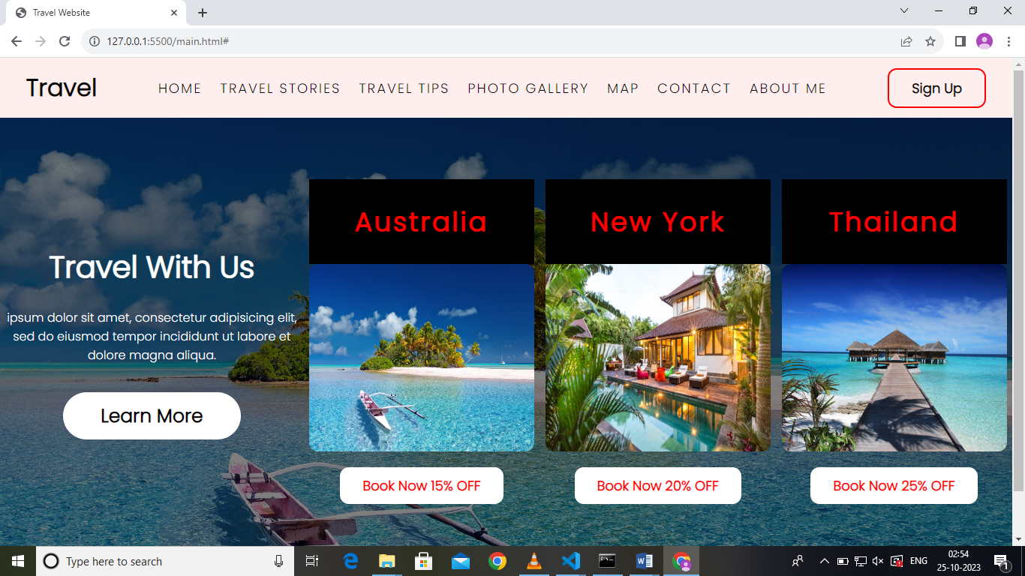

CONCLUSION:

Implementation web app in IBM cloud. The goal is to share travel adventures, its and captivating photos to inspire others to explore the world and create unforgettable memories. Updating the blog. In this solution, we successfully created a personal travel blog hosted on IBM Cloud StaticWeb Apps. By following the problem definition, design thinking, development, anddocumentation phases, we designed and developed an engaging travel blog with captivating .content and an attractive layout. The blog is hosted on IBM Cloud, allowing easy updates and access for users to explore travel stories, tips, and photos, inspiring them to explore thebeauty of the world and forge unforgettable memories.